INDUSTRIAL TRAINING REPORT
‘ASHOK LEYLAND ENNORE UNIT, CHENNAI’

Submitted by

M. MITHUL (2021109023)

In partial fulfillment for the award of the degree Of
BACHELOR OF ENGINEERING
IN MANUFACTURING ENGINEERING


COLLEGE OF ENGINEERING GUINDY ANNA UNIVERSITY: CHENNAI-600025
JUNE – JULY 2024

BONAFIDE CERTIFICATE

Certified that this project on 3D Plant layout and modelling is the
Bonafide work of
M. MITHUL (2021109023)
4th year B.E. Manufacturing Engineering

Under the supervision of
Mrs. Anitha.B, (HR)
&
Mr. Manikandan.R (Asst.Manager, J&T)
Ashok Leyland (Ennore Unit), Chennai - 57
From 3th June 2024 to 15th July 2024

...……………………… …..………..……………
Dr.M. Omkumar Dr. Suthagar Sivan
(Professor and Head) (Asst. Professor)

ACKNOWLEDGEMENT
First I would like to thank Mrs.Anitha. B, HR, of Ashok Leyland (Ennore unit), Chennai for giving me the opportunity to do an internship within the organization.

I also would like to thank Mr. Aravind.AR, Deputy General Manager, Project Planning and Mr. Manikandan.R, Assistant Manager (Jigs and Tool Design), Project Planning and all the people that worked along with me Ashok Leyland (Ennore unit), Chennai with their patience and openness they created an enjoyable working environment.

It is indeed with a great sense of pleasure and immense sense of gratitude that I acknowledge the help of these individuals.

I wish to express our sincere gratitude to Dr.M. Omkumar, Professor and Head, Department of Manufacturing Engineering for providing the support towards the completion of the internship.
We express our heartfelt thanks to, Dr. Suthagar Sivan, Assistant Professor, Department of Manufacturing Engineering for providing for his support and encouragement towards the internship training.
I would like to express my sincere gratitude to ASHOK LEYLAND LIMITED for giving me the wonderful opportunity to gain profound knowledge about 2D Plant layout design to 3D Plant layout design using the 3D EXPERIENCE software.

I am extremely great full to my department staff members and friends who helped me in successful completion of this internship.

ABSTRACT

This is an internship report submitted in the fulfilment of the requirements for the B.E(Manufacturing Engineering). The report provides a consolidated preview of the functional activities of Ashok Leyland (Ennore unit), Chennai.
The referred unit is a core limb of Ashok Leyland, the nation’s pioneering automobile manufacturer. The unique features and policies of the company, which make it a leader without contention and have aided the company in carving an excellent niche for itself in the national and the international arena, have also been referred.
I have visited the plant during the internship period and attained the technical and practical experience, after which was able to compile the report. This report describes the project work done by myself at Ashok Leyland.

INTERNSHIP OBJECTIVES

- Internships are generally thought of to be reserved for college students looking to gain experience in a particular field. However, a wide array of people can benefit from Training Internships in order to receive real world experience and develop their skills.

- An objective for this position should emphasize the skills you already possess in the area and your interest in learning more Knowledge and skills.

- Internships are utilized in a number of different career fields, including architecture, engineering, healthcare, economics, advertising and many more.

- Some internship is used to allow individuals to perform scientific research while others are specifically designed to allow people to gain first-hand experience working.

- Utilizing internships is a great way to build your resume and develop skills that can be emphasized in your resume for future jobs. When you are applying for a Training Internship, make sure to highlight any special skills or talents that can make you stand apart from the rest of the applicants so that you have an improved chance of landing the position.

TABLE OF CONTENTS

CHAPTER | TITLE | PAGE NO
1 | PROFILE OF THE INDUSTRY
 | - ASHOK MOTORS  - ASHOK LEYLAND | 1  2
2 | SOFTWARE SPECIFICATIONS
 | - SOFTWARE  - SHAREABLE PRODUCTS FOR LICENSE | 3  4
3 | INTERNSHIP ROLE AND RESPONSIBILITIES
 | - INTERNSHIP DESCRIPTION | 5
4 | PROJECT DETAILS
 | - WEEKLY OVERVIEW OF INTERNSHIP  ACTIVITY  - LEARNING OUTCOMES AND CHALLENGES FACED | 7  18
5 | CONCLUSION | 18

PROFILE OF THE INDUSTRY

Ashok Leyland is an Indian automobile company headquartered in Chennai, India. It is owned by the Hinduja Group. Founded in 1948, it is the second largest commercial vehicle manufacturer in India, fourth largest manufacturer of buses in the world and 10th largest manufacturer of trucks globally. Operating nine plants, Ashok Leyland also makes spare parts and engines for industrial and marine applications. It sold approximately 140,000 vehicles (M&HCV + LCV) in FY 2016.
It is the second largest commercial vehicle company in India in the medium and heavy commercial vehicle (M&HCV) segment, with a market share of 32.1% (FY 2016). With passenger transportation options ranging from 10 seaters to 74 seaters (M&HCV = LCV), Ashok Leyland is a market leader in the bus segment. In the trucks segment Ashok Leyland primarily concentrates on the 16 to 25-ton range. However, Ashok Leyland has a presence in the entire truck range, from 7.5 to 49 tons.

Ashok Motors
Ashok Motors was founded in 1948 by Raghunandan Saran. He was an Indian freedom fighter from Punjab. After Independence, he was persuaded by India's first Prime Minister Nehru to invest in a modern industrial venture. Ashok Motors was incorporated in 1948 as a company to assemble and manufacture Austin cars from England, and the company was named after the founder's only son, Ashok Saran. The company had its headquarters in Rajaji Saalai, Chennai (then Madras) with the plant in Ennore, a small fishing hamlet in the North of Chennai.

The company was engaged in the assembly and distribution of Austin A40 passenger cars in India. Under Leyland 8 Raghunandan Saran had previously negotiated with Leyland Motors of England for assembly of commercial vehicles as he envisioned commercial vehicle were more in need at that time than were passenger cars. The company later under Madras State Government and other shareholders finalized for an investment and technology partner, and thus Leyland Motors joined in 1954 with equity participation, changing the name of the company to Ashok Leyland.

Ashok Leyland
Ashok Leyland then started manufacturing commercial vehicles. Under Leyland's management with British expatriate and Indian executives the company grew in strength to become one of India's foremost commercial vehicle manufacturers. The collaboration ended sometime in 1975 but the holding of British Leyland, now a major British Auto Conglomerate as a result of several mergers, agreed to assist in technology, which continued until the 1980s. After 1975, changes in management structures saw the company launch various vehicles in the Indian market, with many of these models continuing to this day with numerous upgrades over the years. Ashok Leyland has seven manufacturing plants

1.2.1 Ennore Plant, Chennai.
1.2.2 Hosur Plants Unit I, Unit II
    - Alwar, Rajasthan.
    - Bhandara, Maharashtra.
    - Pantnagar, Uttarakhand

2. SOFTWARE SPECIFICATIONS

SOFTWARE

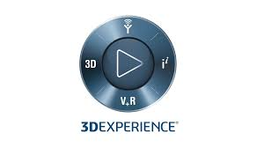
3DEXPERIENCE is a software platform developed by Dassault Systems. It serves as a collaborative environment that integrates various aspects of the product development process. Here are some key features and functionalities:
- Collaboration: Connects different stakeholders in real-time, allowing for better teamwork and communication.
- 3D Design: Provides advanced tools for 3D modelling and design, supporting various industries such as automotive, aerospace, and consumer goods.
- Product Lifecycle Management (PLM): Manages the entire lifecycle of a product, from initial concept through to design, manufacturing, and support.
- Simulation: Facilitates realistic simulation of products under various conditions and applications to optimize performance.
- Data Management: Centralizes data storage and management, ensuring that stakeholders have access to the most up-to-date information.
- Innovation: Encourages innovation by integrating tools for ideation, testing, and iteration.
- Customizability: Offers customizable solutions tailored to specific industry needs, including aerospace, automotive, industrial equipment, high tech, and life sciences.
- Cloud Solutions: Provides cloud-based options for accessibility and scalability.
By leveraging these features, organizations can improve their design and engineering processes, enhance productivity, and drive innovation.

2.2 SHAREABLE PRODUCTS FOR LICENSE
- PLA (Product Lifecycle Assessment), within the 3DEXPERIENCE context, generally refers to the assessment and management of a product’s lifecycle. It involves the stages a product goes through from concept, design, manufacturing, and use, to disposal. The module helps in:
  - Sustainability Analysis: Assessing the environmental impact of products.
  - Lifecycle Cost Management: Evaluating the costs associated with each stage of the product lifecycle.
  - Compliance Management: Ensuring products meet regulatory and industry standards throughout their lifecycle.

- KDI (Key Data Indicators) refers to tools and functionalities that allow users to track and analyze critical performance indicators and metrics. In 3DEXPERIENCE, KDI functionalities might include:
  - Dashboard Creation: Building and customizing dashboards that display real-time data and metrics relevant to product development and operations.
  - Performance Metrics: Monitoring key performance indicators (KPIs) to measure the efficiency and effectiveness of various processes.
  - Data Integration: Integrating data from different modules and sources to provide a comprehensive view of performance across the organization.

- MES (Manufacturing Execution System) in the 3DEXPERIENCE platform is a crucial module designed to control and monitor the manufacturing process in real-time. It includes functionalities such as:
  - Production Scheduling: Planning and scheduling production activities to optimize resource utilization.
  - Quality Management: Implementing quality control measures and tracking quality metrics to ensure product standards are met.
  - Work Order Management: Generating, tracking, and managing work orders throughout the manufacturing process.
  - Traceability: Ensuring traceability of materials and components throughout the manufacturing workflow for quality assurance and compliance.
The above-mentioned licenses were used for 3D plant layout design project.

3. INTERNSHIP ROLE AND RESPONSIBILITIES

3.1 INTERNSHIP DESCRIPTION
The internship opportunity offered by Ashok Leyland (Ennore Unit) is for completing a project work on 3D plant designing of Ashok Leyland plants in India and the project work depending on myself is on 2D to 3D conversion of plant layout to solid models for industry 4.0 development of Ashok Leyland company.
The whole Projects was undergone in Ashok Leyland organization was done by Project Planning (PP) department which is located in Ashok Leyland Ennore.
I glad to inform that I was selected to work in Project Planning department and to work in an important project for the development of Industry 4.0 of Ashok Leyland. Here I assigned to the 2D to 3D conversion of shop in the alwar plant and bhandara plant.

The 3D model that I made will be converted to digital form through JavaScript coding for technological development of Ashok Leyland company.
Here I was worked under Mr. Aravind.AR, Deputy General Manager, Project Planning and Mr. Manikandan.R, Assistant Manager (Jigs and Tool Design), Project Planning. Under this team they guide me to understand the layouts and modelling the plant with patience. The 2D Layouts of all the shops and plant are provided as .dwg file format and the project work was clearly explained by Manikandan sir through SOP videos.
Here we had come with a new platform to study about the conversion of 2D to 3D using 3D Experience software and learnt some civil knowledge apart from mechanical.
Then the modelling software of 3D Experience was one of the new platform to improve my skills in 3D modelling apart from Solid works, AutoCAD. I was assigned for the shop 4 2D to 3D conversion of Ashok Leyland Plant, in Bhandara plant, Maharashtra. The Shop 4 layout contains pillars, walls, windows, rooms, Truss, doors, roof, office, toilets etc. Here we are a team of 12 members and the 11 members were assigned to model shops and one were assigned for the overall site plan.

The overall time taken for conversion is about 6 weeks and the whole plant was modelled and presented to the Mr. Clement Ravi, Head of the PP and some officials, then they appreciate us for our coordination within teams.

4.PROJECT DETAILS

WEEKLY OVERVIEW OF INTERNSHIP ACTIVITY

WEEK 1:
1st Week | Date | Day | Completion of Work
1st Week | 03.06.2024 | Monday | Introduction to Ashok Leyland Project Planning and 3D  Experience software
1st Week | 04.06.2024 | Tuesday | Learned to convert 2D to 3D plant layout design and construct a tree structure for Physical product
1st Week | 05.06.2024 | Wednesday | Learned to design a structural elements for civil works.
1st Week | 06.06.2024 | Thursday | Received a hosur plant layout as a dwg file and analyzed plant layout

At first day Mrs.Anitha. B, HR, of Ashok Leyland (Ennore unit), gave some necessary guidelines and rules at Learning center and I moved to Project planning department and a brief introduction about the Project Planning and Ashok Leyland was delivered by Mr. Manikandan sir and he explained about the project were i going to work and he introduced to a new software 3D Experience. He instructed to watch SOP videos and Started Studying and Taken notes of 3D EXPERIENCE DELMIA using SOP video.
On the second day, Hands on experience on 3D EXPERIENCE DELMIA software and Learned to convert 2D to 3D plant layout design and construct a tree structure for Physical product and its corresponding children parts.
On the third day, learned to design a structural element for civil works namely– Pillars, Walls, Truss, Roof, Claddings and 3D parts like Doors, Windows, Ventilators, Shutters, Sliding Doors, Glazing Work.

On the fourth day, received a Hosur plant layout as a dwg file format and started to analyze the Hosur plant layout with the help of Google earth and Compared the size of land area and shop positions with the actual satellite image.

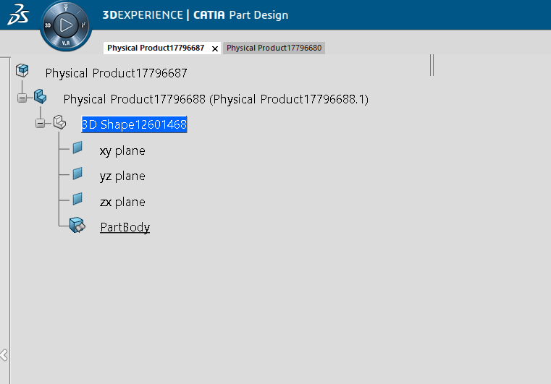

WEEK 2:

2nd Week | Date | Day | Completion of Work
2nd Week | 10.06.2024 | Monday | Hands on experience with software and hosur plant layout design.
2nd Week | 11.06.2024 | Tuesday | Started to work on the project. Alwar plant Shop 11 was assigned and analyzed its 2D drawings
2nd Week | 12.06.2024 | Wednesday | Designed Walls and Windows for the shop 11 of Alwar plant
2nd Week | 13.06.2024 | Thursday | Designed truss for the shop 11 of Alwar plant

On the first day imported the overall layout of Hosur plant – II in 3D experience. and started practicing the design of Hosur plant.
On the second day myself and my team mates are assigned to Alwar plant and to start the project work. I had gone through the shop 11 of the alwar plant and imported the 2D layout inside the software and started to design the plant. the pillars of the shop 11 of Alwar plant was completed and then the walls were started.
On the third day, the walls were completed and then started to design the windows of shop 11.
On the fourth day, Assembly of windows was completed on the two sides and started to design the truss of shop 11.
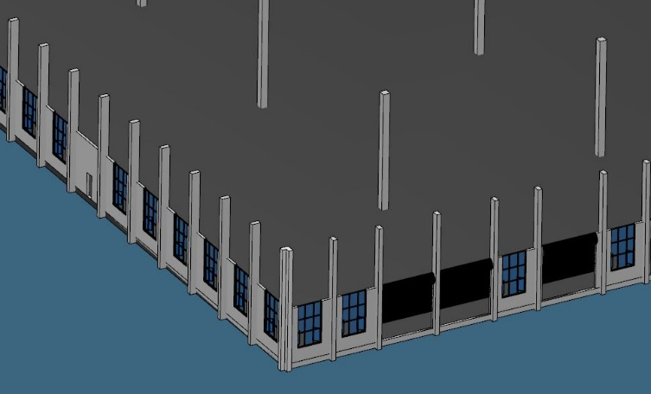
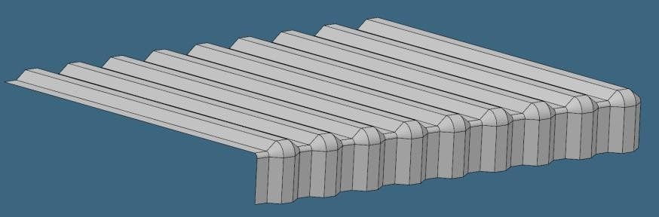

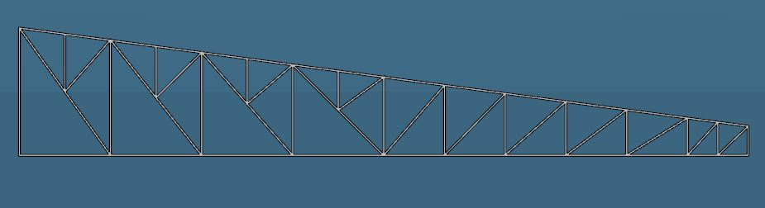

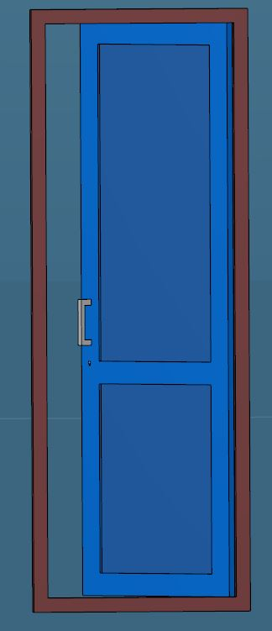
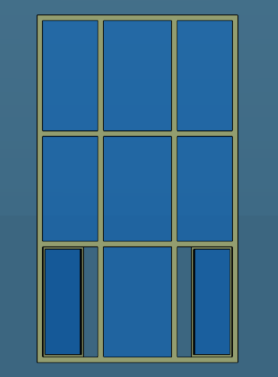

WEEK 3:

2nd Week | Date | Day | Completion of Work
2nd Week | 18.06.2024 | Tuesday | Completion of Windows and shutters in shop 11
2nd Week | 19.06.2024 | Wednesday | Completion of Ventilators in shop 11 of Alwar plant
2nd Week | 20.06.2024 | Thursday | Completion of cladding in shop 11 of Alwar plant
2nd Week | 21.06.2024 | Friday | Assigned shop 4 of Bhandara plant and Designed windows, ventilators, door.

On the first day, design of truss and roof was completed and placed to the respective place and then started building toilet outside the shop. Assembly of the windows and shutters on the remaining side was completed.
On the second day, first half was started to design the ventilator and assembled in the shop 11. Second half went to the shop 5 (Ennore plant) and learned about the Poke Yoke, Quality Assurance and Quality Control.
On the third day, started to design the North and East face Cladding. And then assembled in the respective place. Due to the unavailability of the inputs to Alwar plant was paused.
On the fourth day, myself and my team mates are assigned to Bhandara plant. I had gone through the shop 4 of the Bhandara plant and imported the 2D layout inside the software and started to design the plant. the pillars of the shop 4 of Bhandara plant was completed and then designed windows, ventilators, door.

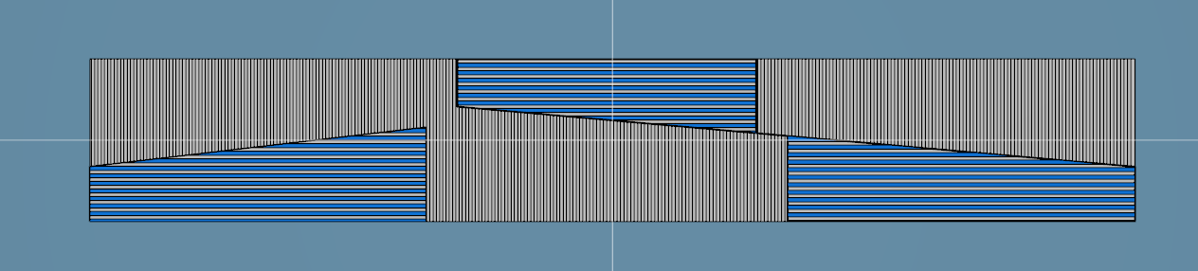

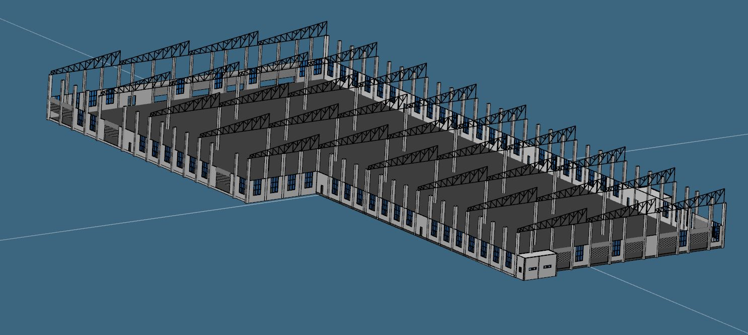

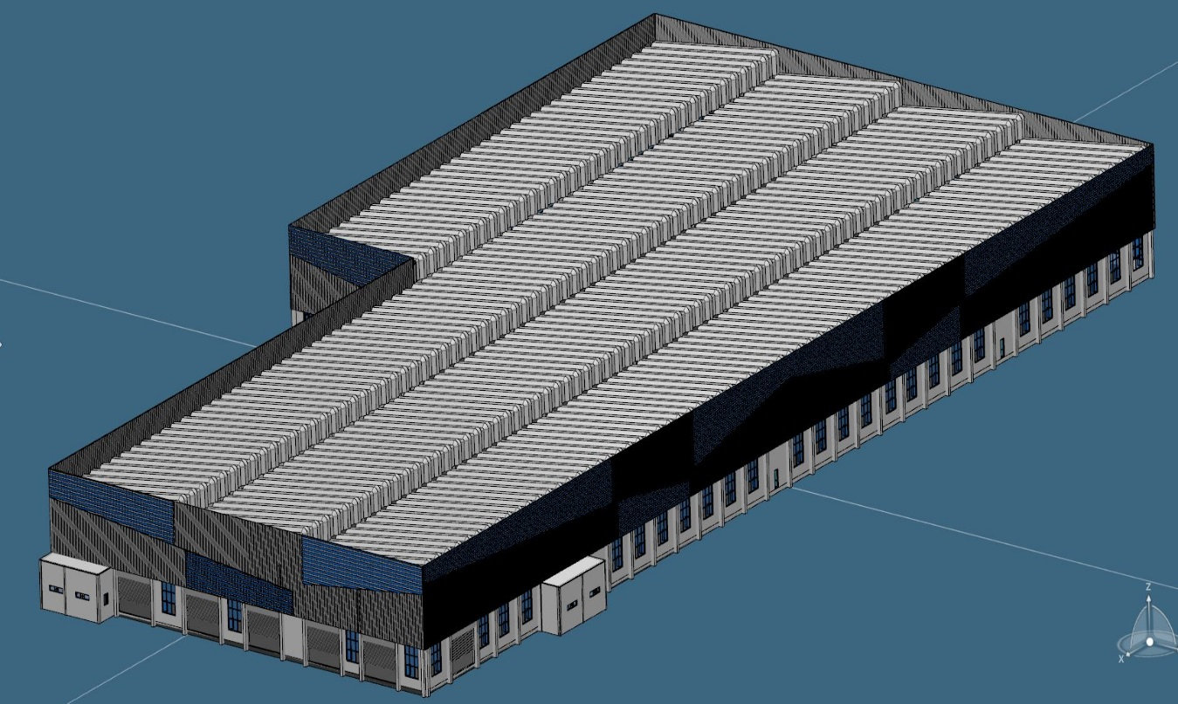

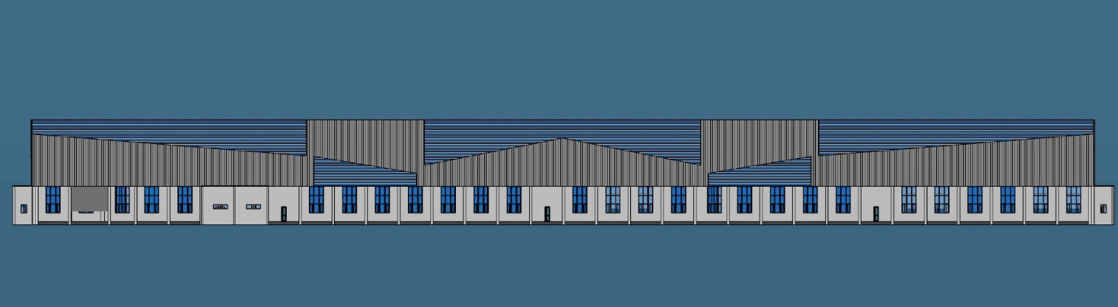

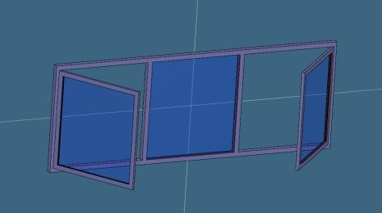
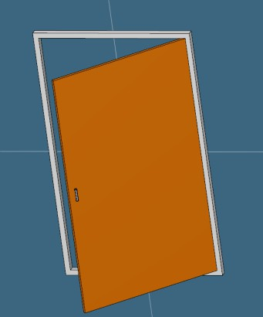
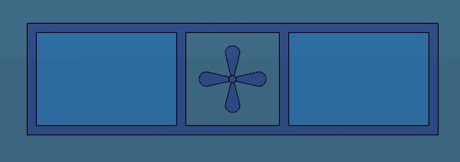

WEEK 4:

4th Week | Date | Day | Completion of Work
4th Week | 24.06.2024 | Monday | Completion of walls and Windows ,Ventilators, truss and roof.
4th Week | 25.06.2024 | Tuesday | Completion of cladding and roof side walls.
4th Week | 26.06.2024 | Wednesday | Completion of small buildings of the plant
4th Week | 27.06.2024 | Thursday | Completion of overall shop 4 in Bhandara plant
4th Week | 28.06.2024 | Friday | Started to design an outside buildings in bhandara plant.

On the first day, the walls were completed in shop 4 and then started to design the truss, roof. Assembled the already designed Rolling shutters, Windows, Ventilators, truss and roof.
On the second day, started to design cladding and roof side walls. started working on the toilet and compressor room pillars, walls, roof had been completed (totally 2 toilets).
On the Third day, the completion small buildings, the small buildings include the blower room, south side toilet, transformer room, double floor office 1, double floor office 2.
On the fourth day also worked on the remaining small buildings, the small buildings include pump room, shed and cluch housing, fork lift maintenance. Design of the overall ramp and staircase is completed for shop 4. Atlast overall shop 4 is completed in the Bhandara plant
On the fifth day, the work was assigned me on the bhandara buildings. Design of overhead pump room and security office was completed.

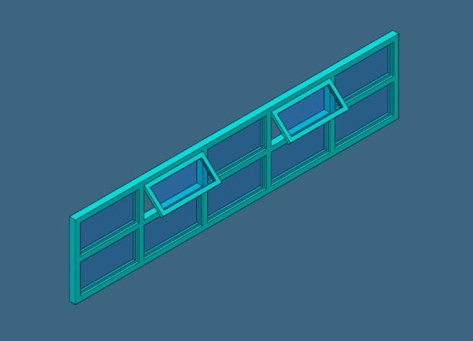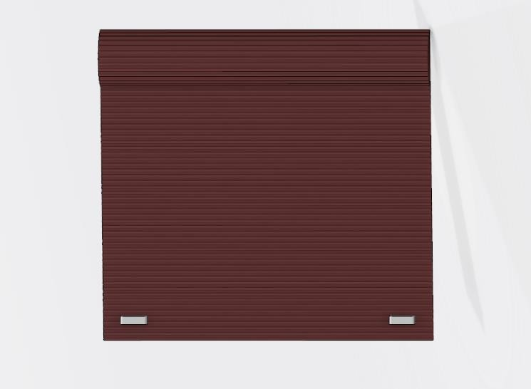

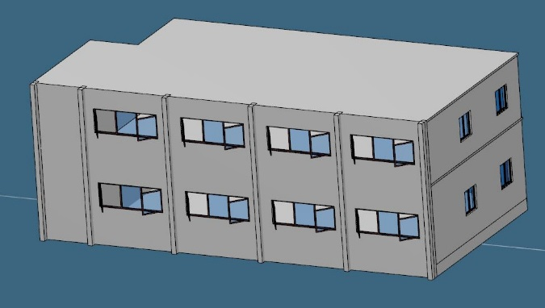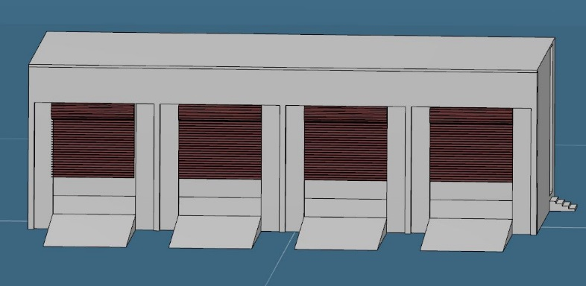

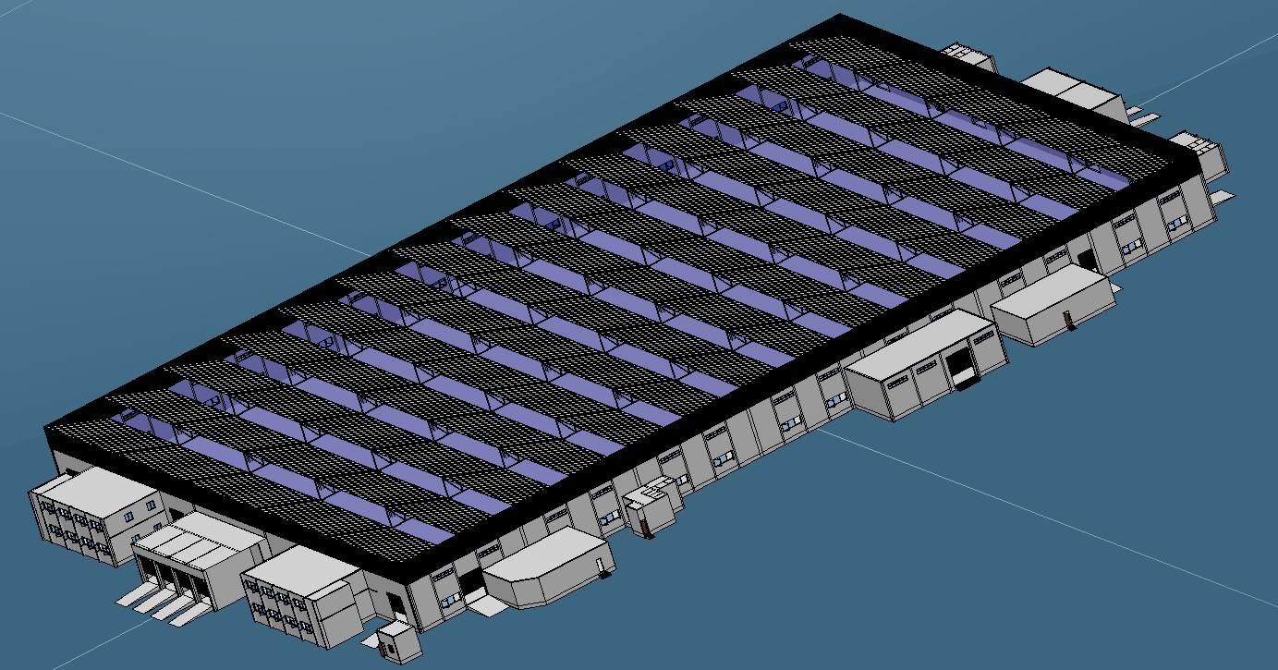
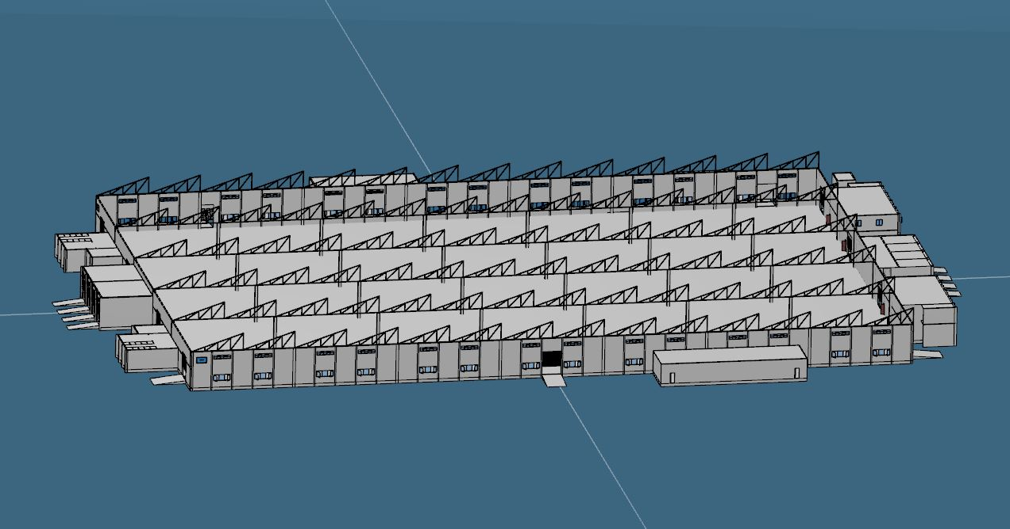

WEEK 5:
5th Week | Date | Day | Completion of Work
5th Week | 01.07.2024 | Monday | Completion of outside buildings in bhandara plant.
5th Week | 02.07.2024 | Tuesday | Walk through video was taken and uploaded in folder
5th Week | 03.07.2024 | Wednesday | Completion of placing the tress in the Bhandara plant, helped to teammate
5th Week | 04.07.2024 | Thursday | Completion of placing the bush,car,truck in the Bhandara plant, helped to teammate
5th Week | 05.07.2024 | Friday | Completion of the name plate in the Bhandara plant.

On the first day, Design of control room 1 and control room 2, bio chemical disposal pit, Shed C, Shed D, pump room and motor room is completed and Assembled the windows and doors in the security office is completed.
On the second day, the walk through video was taken for shop 4 bhandara plant and it is uploaded in my folder. Buildings allotted to me on the bhandara plant is completed.
On the third day, completed all assigned work and worked in the Bhandara site plant to place the tress in respective place.
On the fourth day, worked in the Bhandara site plant to place the bush, car, truck in respective place.
On the fifth day, designed the name plate of all shops and fixed it in the respective place and helped teammate to rearrange the tress in bhandara plant.
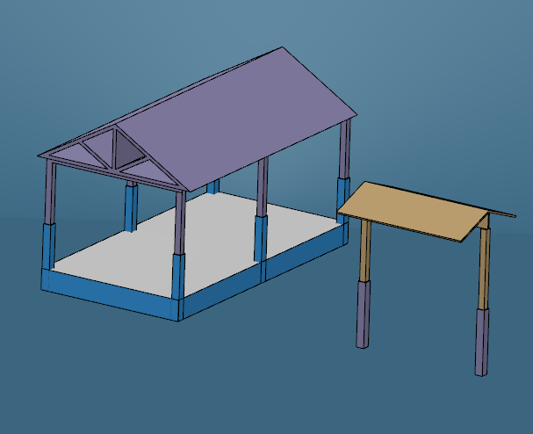
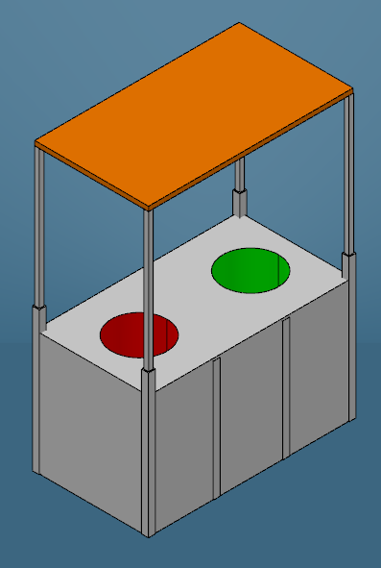

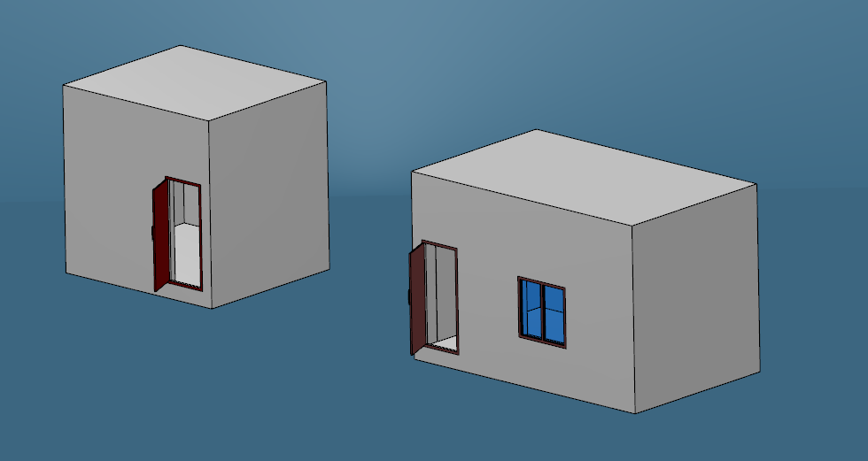

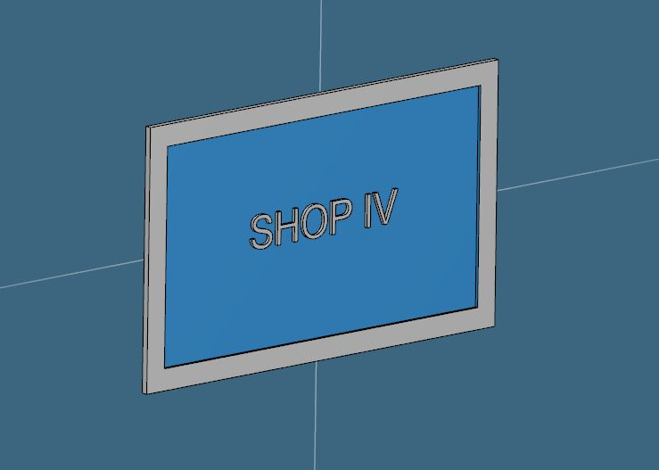
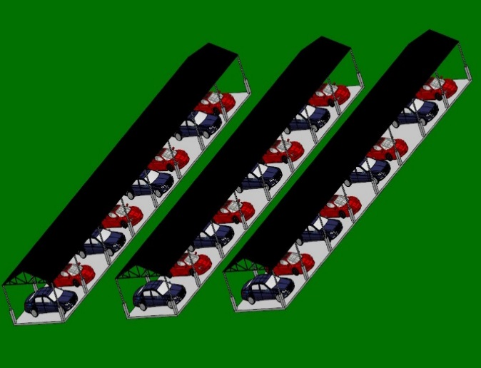

WEEK 6:
6th Week | Date | Day | Completion of Work
6th Week | 08.07.2024 | Monday | Completion of overall bhandara plant and walk through video was taken.
6th Week | 09.07.2024 | Tuesday | Completion of shop 11 alwar plant and Analyzing the inputs of all shops in alwar plant.
6th Week | 10.07.2024 | Wednesday | Assigned to design the shop 2 in the alwar plant. Completion walls and pillars in shop 2.
6th Week | 11.07.2024 | Thursday | Completion of truss,cladding,boom tie,pro ofice1&2,restroom of shop 2 in alwar plant .
6th Week | 12.07.2024 | Friday | Completion of overall shop 2 in alwar plant

On the first day, final changes of the shop 4 in bhandara plant was made and overall bhandara plant was completed and walk through video was taken.

On the second day, left out work in the alwar plant shop11 was completed and the overall shop 11 Alwar plant is completed and started analyzing the old inputs with the new inputs.

On the third day, analyzing of the alwar plant was completed and reported to the Manikandan sir and assigned me to model a shop 2 in alwar plant. Completed designing walls and pillars in shop 2.

On the fourth day, completed designing a truss, cladding, boom tie, pro office 1&2, restroom of shop 2.

On the fifth day, designed the door, shutters were completed. Final changes of the shop 2 alwar plant was made and completed the shop 2 in alwar plant. Overall work assigned for me is completed.
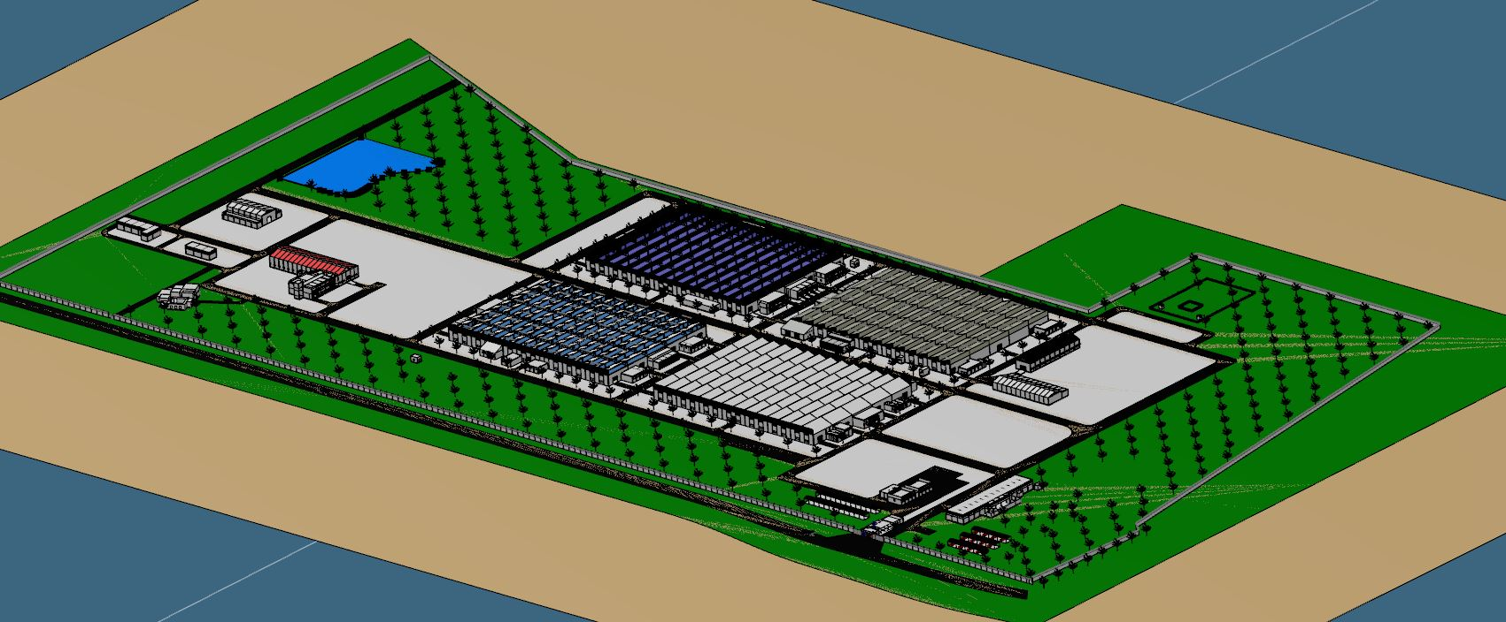

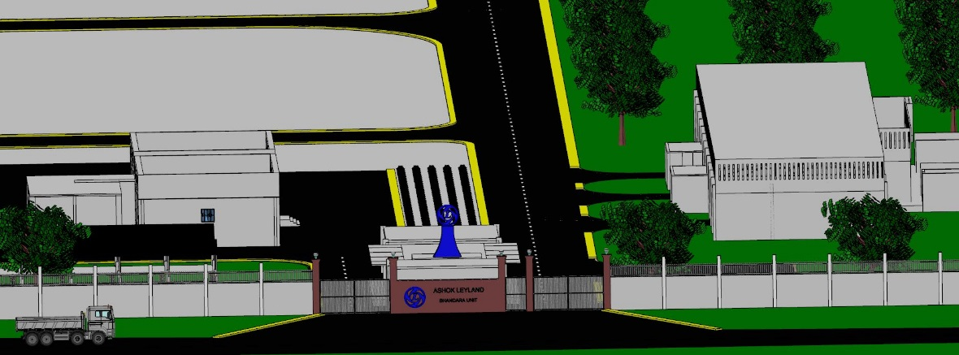

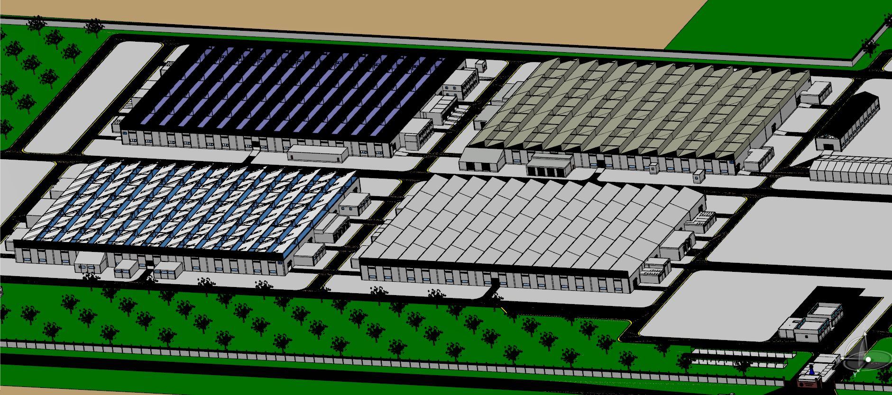

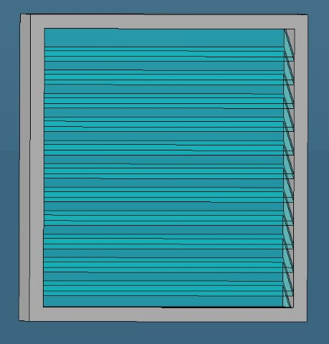
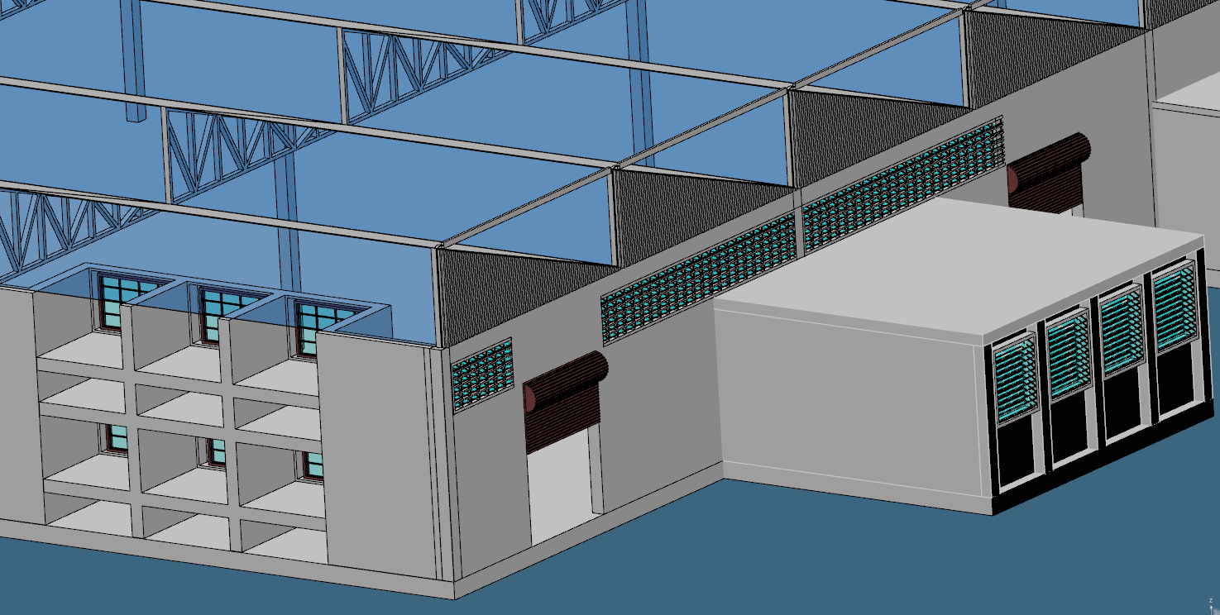

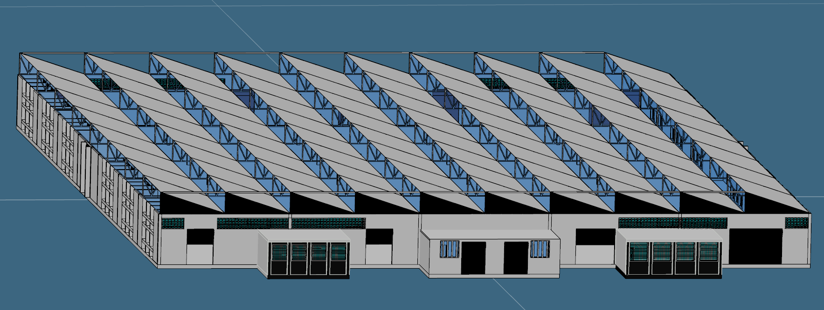

  - LEARNING OUTCOMES AND CHALLENGES FACED

From the internship offered by Ashok Leyland company is much more than useful for me to gain some skill and knowledge in 3D design software. This software experience contributed to my professional growth through enhancing my technical skills, Collaboration and communication improved while using a cloud based software, increased efficiency in design processes and techniques like data management and design automation, enhanced problem solving abilities like design improvement in an iterative manner, exposure to industry standards and practices, and this helps me to improve my organizational management skills and to improve my professional growth.

5. CONCLUSION

In conclusion, my internship at Ashok Leyland has been a transformative journey. I expanded my proficiency with design software like CATIA and SolidWorks, and I also learned a new software, 3DEXPERIENCE, which provided valuable experience. Through my own efforts, I mastered AutoCAD for 2D design, enhancing my understanding of this crucial aspect of design.

This internship taught me how to navigate challenges within an organization, significantly improving my communication and design skills. Completing projects boosted my confidence in the design field, and adapting to the organizational environment provided invaluable experience.

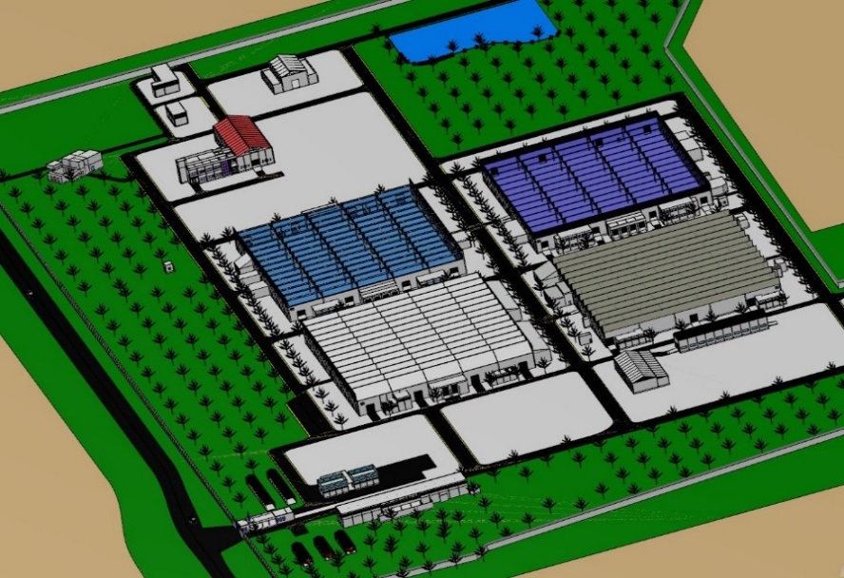

I am deeply thankful to Ashok Leyland for this opportunity and their unwavering support throughout my internship. This experience has paved the way for my future career aspirations and has inspired me to continue working in the design field, particularly in creating real-time applications.

